**FINANCIAL MODELLING:**

This model can be provided to different product-based companies for prediction their customer behaviour. The market profit earned by this model can be calculated as:

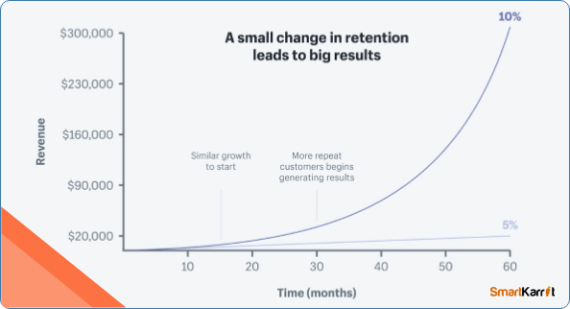

* **PROFIT EARNED BY THE MODEL**

**Market profit = (Number of Customers * Average Revenue per Customer * Subscription Duration) - (Acquisition Cost * Number of New Customers + expenditure cost)**

Number of Customers is the total number of customers in each period

Average Revenue per Customer is the average revenue generated per customer in a given period

Subscription duration is the duration for which customer has taken the subscription.

Acquisition Cost is the cost of acquiring a new customer

Number of New Customers is the number of new customers acquired during the given period

Expenditure cost is the cost spent in miscellaneous like salary, maintenance etc

Now, let us assume that number of customers be 1000, average revenue per customer be Rs. 10000 per month, acquisition cost be 3000 with new customers be 200 and expenditure cost be 2000 and let T be 1 year.

Market profit = (1000*10000* T) – (3000*200 + 2000)

Market profit= (10000000*T)- 602000

Market Profit= (10000000*1)-602000

Market profit= 9,398,000

* **PROFIT EARNED BY INDUSTRY USING MODEL**

Here, the profit earned by the industries using our customer churn model is been elaborated. We can derive the equations for the profit calculation of the basis of two models

**Linear financial model**:

If the cost of acquiring new customers is constant, the total profit for a given period can be calculated as follows:

Total profit = Total revenue - Total costs

Total revenue = Price per customer * Total number of customers

Total costs = Production costs + Maintenance costs + Cost of retaining existing customers + Cost of acquiring new customers

Assuming that the churn rate is a linear function of time, we can use the following equation to estimate the number of customers who will churn:

Churn rate = a * t + b

Where t is the time period (in months or years), a and b are coefficients that can be estimated using linear regression.

Using this churn rate, we can estimate the number of customers who will churn in the given period:

Number of churned customers = Churn rate * Total number of customers

Substituting this into the equation for total revenue and costs, we get the following equation for total profit:

Total profit = (Price per customer * Total number of customers) - (Production costs + Maintenance costs + Cost of retaining existing customers + Cost of acquiring new customers) - (Churn rate * Total number of customers * Cost of retaining existing customers)

**Exponential financial model**:

If the churn rate follows an exponential decay function, we can use the following equation to estimate the number of customers who will churn:

Churn rate = a * exp (-b * t)

Where t is the time period (in months or years), a and b are coefficients that can be estimated using non-linear regression.

Using this churn rate, we can estimate the number of customers who will churn in the given period:

Number of churned customers = Churn rate * Total number of customers

Substituting this into the equation for total revenue and costs, we get the following equation for total profit:

Total profit = (Price per customer * Total number of customers) - (Production costs + Maintenance costs + Cost of retaining existing customers + Cost of acquiring new customers) - (Churn rate * Total number of customers * Cost of retaining existing customers)

These equations can be used to estimate the financial impact of customer churn and to identify strategies to reduce churn and increase profits.